**Back End Class Diagram:**

This depicts the modular design followed to implement the functionalities and store the details in the backend database and process then using through the program

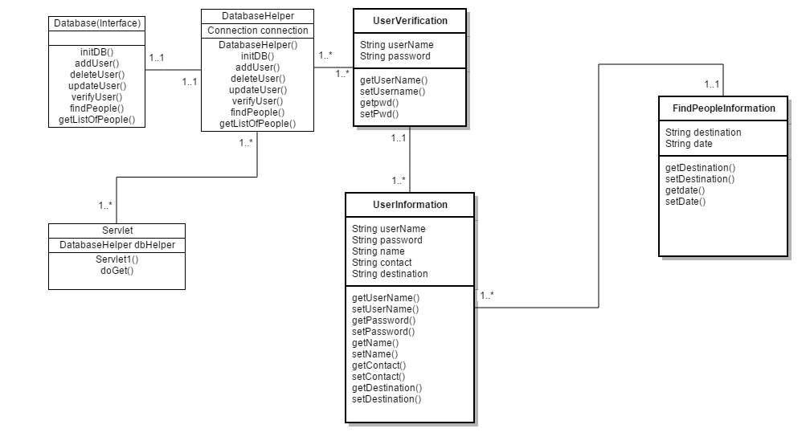

**Database Schema:**

This depicts the backend design implementation of the Database.

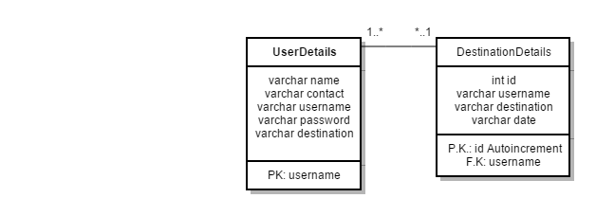

**Flow Chart:**

This depicts the work flow functioning of the App for different Test cases.

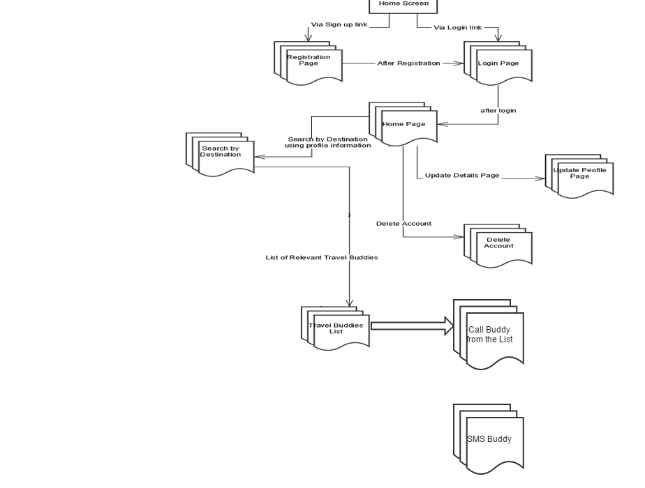

**Front End Class Diagram:**

This depicts the interaction between the activities and the modules defined in the front end.

